Paper Title

1. **Preprocessing: Filtering & Segmentation**

The segmentation process is accomplished by assigning the uninterrupted sequences of arrhythmia beats into the corresponding arrhythmia groups. Each segment consists of only one ECG beat type with 99 samples to the left of the first R peak and 160 samples to the right of the last identified uninterrupted R peak. Table 1 shows an overview of the total number of ECG segments obtained from the MIT-BIH arrhythmia database with the corresponding sample length range.

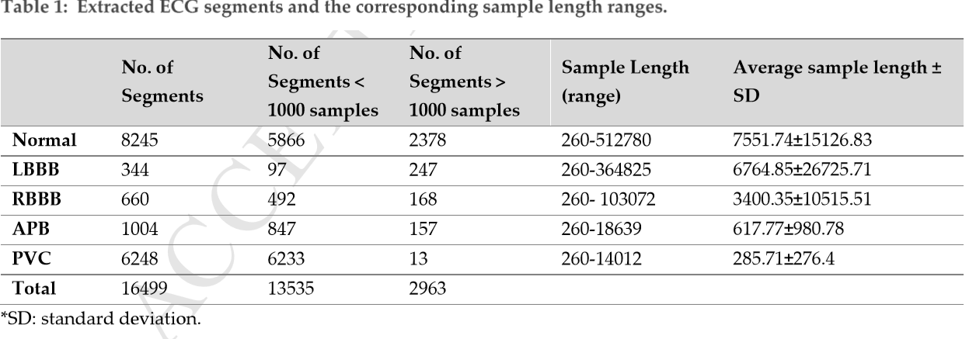

1. **Feature Extraction**

* Deep learning model

1. **Classification & Classifier**

using combination of CNN and long short-term memory ( LSTM ) techniques

left bundle branch block (LBBB), right bundle branch block (RBBB), atrial premature beats (APB) and premature ventricular contraction (PVC) on ECG signals

1. **Accuracy**

achieving an accuracy of 98.10%, sensitivity of 97.50% and specificity of 98.70% using ten- fold cross validation strategy

1. **Two Leads or One Lead ? In case of two leads .. how classification of two leads is merged to have final decision ?**
2. **Classes**

five different classes of arrhythmias using the ECG signals